TR23086 OHG – Integration Mapping

Functional Specification

Author: Richard Collins

Amendment History

|  |  |  |  |
| --- | --- | --- | --- |
| **Date** | **Name** | **Version** | **Comments** |
| 10/10/2014 | Richard Collins | 1.0 | Initial Version |
|  |  |  |  |
|  |  |  |  |

Table of Contents

1 Introduction and Overview 3

1.1 Document Purpose 3

1.2 Distribution List 3

1.3 Related documents 3

1.4 Glossary 3

1.5 Related issues for this release 4

1.6 Issues that will be fixed as part of this issue 4

2 Business Summary 5

2.1 Existing Functionality 5

2.2 User Requirement 5

2.3 Trace Requirement 5

3 Solution Summary 6

3.1 Separate sub-sections for larger issues, divided into groups, e.g. ‘System level’ , ‘Reports’. 6

3.2 Business benefit 6

3.2.1 Investors 6

3.2.2 Agents 6

3.2.3 Owners 6

4 Solution Detail 7

5 Other Notes 32

5.1 Performance 32

5.2 Audit Considerations 32

5.3 Limited Access 32

5.4 Scheduler 32

5.5 Other Modules 32

# Introduction and Overview

*Indicate the origin of the issue and a brief description (in one or two short paragraphs).*

Issue description is: *<issue description (in full, and without any amendment)>*

*If the issue relates to a Helpdesk call:-*

Helpdesk ref: *<helpdesk ref>*

Client: *<client name>*

Date Reported: *<date reported>*

Comments are: *<all comments, copied without amendment>*

Review notes: *<all review notes, copied without amendment>*

## Document Purpose

I*ndicate whether the document is intended for user sign-off, internal discussion, and/or as the definitive reference document for coding and testing. Most of the time this will just be: ‘For internal circulation, comment and sign-off.’*

## Distribution List

|  |  |  |  |
| --- | --- | --- | --- |
| **Name** | **Initials** | **Role** | **Signed-off** |
|  |  |  |  |
|  |  |  |  |

## Related documents

*These can be any documents that backup the analysis in this spec, e.g. client specifications, or associated internal documents, e.g. the technical specification.*

|  |  |  |
| --- | --- | --- |
| **Name** | **Description** | **Link** |
|  |  | *<hyperlink to document>* |
|  |  |  |

## Glossary

*Any terms that the specification recipients or the developers or QA testers might not be familiar with, e.g. ‘sticky settings’ , ‘approved fonts’ .*

|  |  |
| --- | --- |
| **Term** | **Description** |
|  |  |
|  |  |

## Related issues for this release

*Any issues that have to be done in the same release as this issue.*

|  |  |
| --- | --- |
| **Issue Ref** | **Description** |
|  |  |
|  |  |

## Issues that will be fixed as part of this issue

*Any issues that will be fixed as a consequence of the amendments defined in this issue.*

|  |  |
| --- | --- |
| **Issue Ref** | **Description** |
|  |  |
|  |  |

# Business Summary

## Existing Functionality

*Only as appropriate; will be more relevant to larger issues, especially if any key contacts in the distribution list are known to be unfamiliar with certain aspects of the application.*

## User Requirement

*Define the business problem that is being addressed, NOT just a description of what the user requires to solve the business problem, e.g.*

*“We require Data Archiving” may be the user’s request.*

*On questioning the customer it was discovered that the users are having trouble seeing recent data in a data tree, and are spending time searching the tree for up-to-date data.*

*A simple filter added to the tree makes identifying relevant data quicker and more accurate.*

*If the business problem is not clear or cannot be obtained, this fact must be clearly documented*

*Reproduce any user discussions here, indicating date and time.*

*If the user has supplied a document then refer to its location.*

*If the requirement was sent in an e-mail, reproduce the whole e-mail here.*

*If there is a ballpark document, reproduce the text of the ballpark here.*

*If there has been no contact with the user just state: ‘*This issue has not been discussed with any of our users.’

## Trace Requirement

*If we would like additional functionality, over-and-above the user’s requirement, state it here.*

*If there are other issues that will be completed at the same time, list them along with their full issue description.*

# Solution Summary

*All routines and windows affected should be mentioned here, and how they contribute to the solution, but obviously in brief - remember that one or more of the spec reviewers may be very time-poor.*

*As rule-of-thumb, keep this section to one page per fifteen pages of detail.*

*All of this section should be text only, no screenshots.*

*If any alternative proposals had been made – possibly they had been stated in the issue description or in other documents or e-mails attached the issue – but have been rejected, state why they have been rejected.*

## Separate sub-sections for larger issues, divided into groups, e.g. ‘System level’ , ‘Reports’.

## Business benefit

*Indicate any particular performance or processing efficiency benefits that will help our users in each of the following sections.*

### Investors

### Agents

### Owners

# Solution Detail

Company

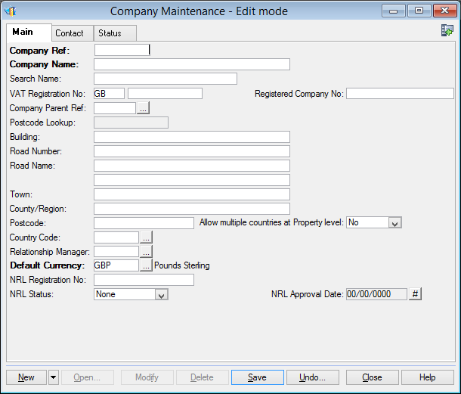

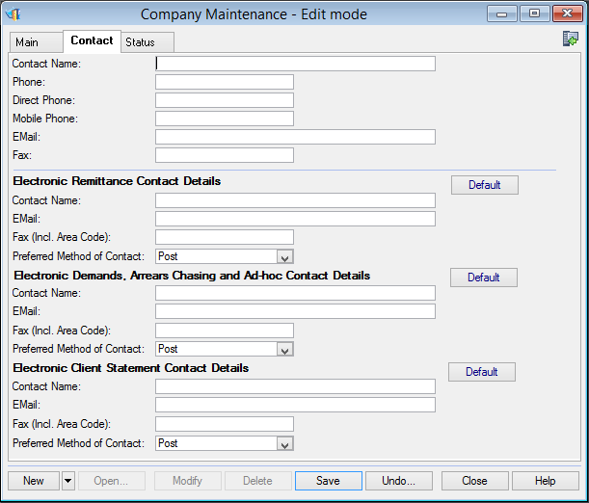

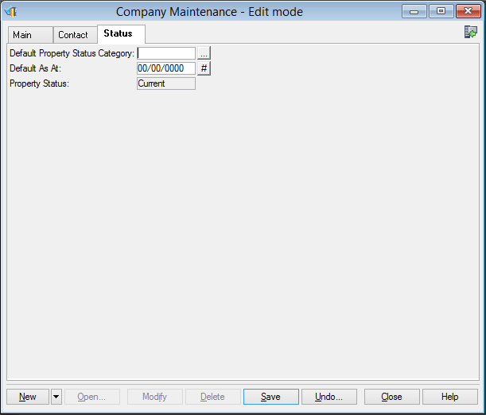

Company Account

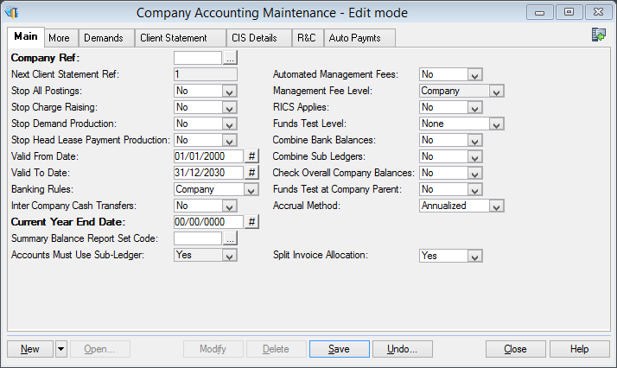

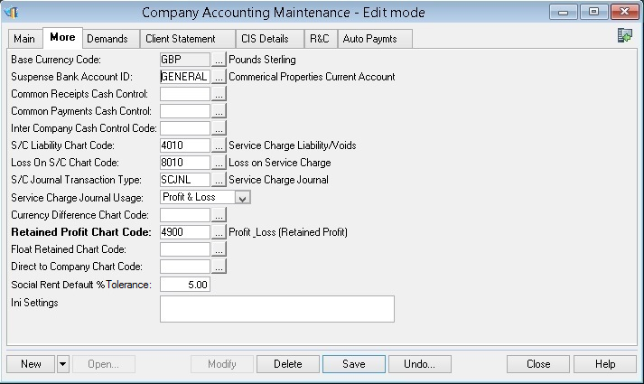

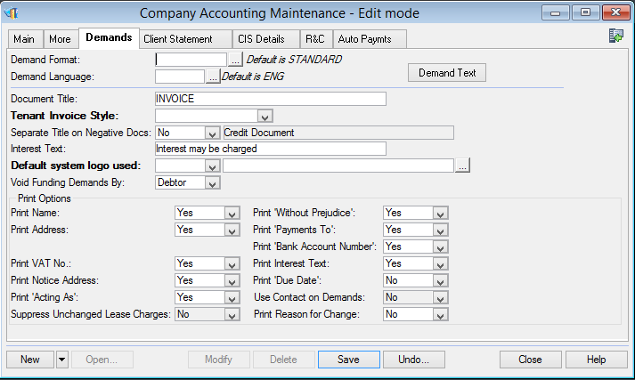

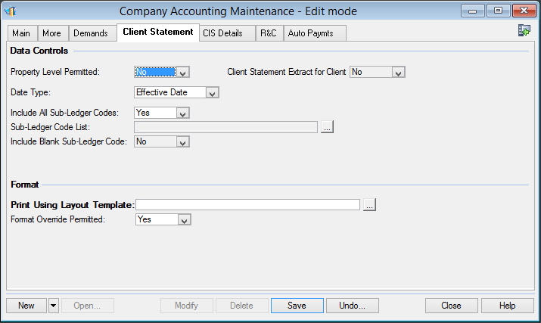

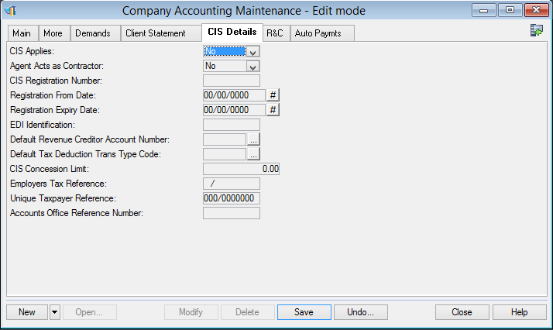

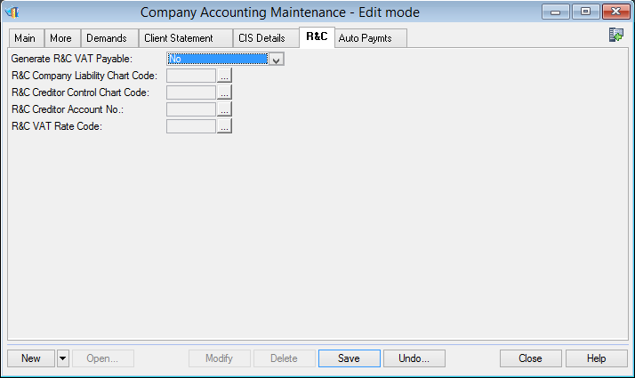

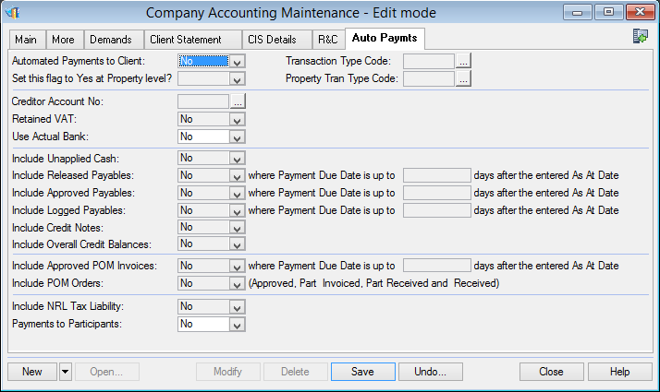

Estate

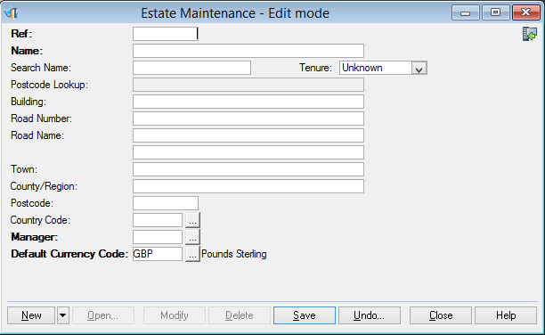

Property

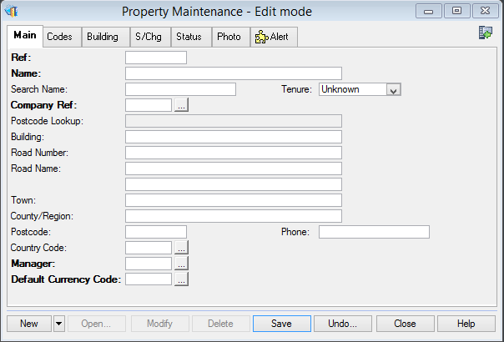

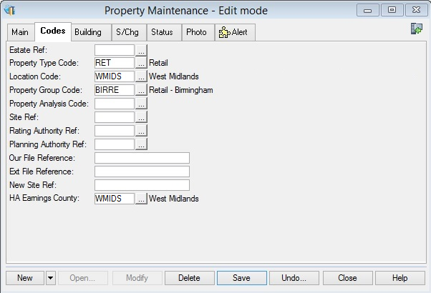

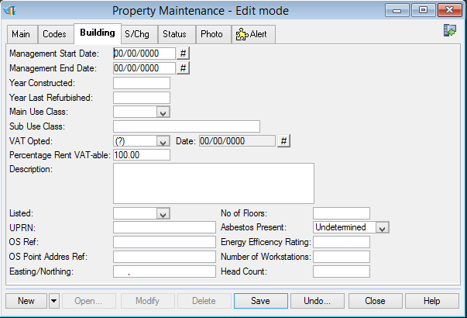

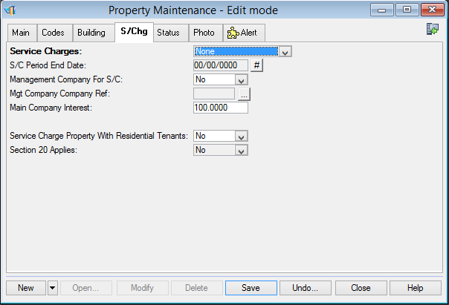

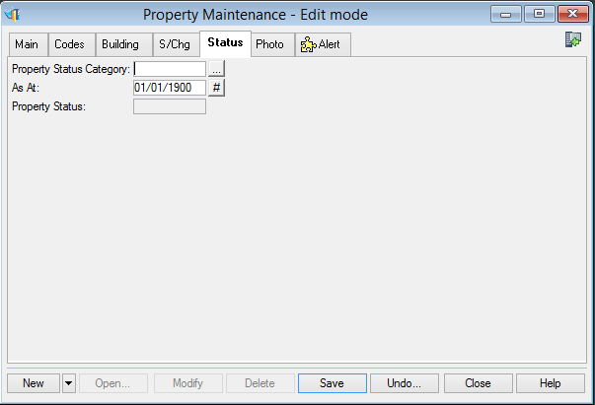

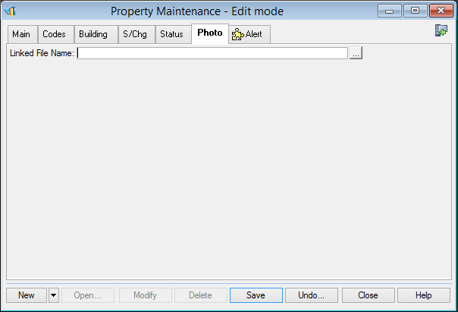

Property Accounting

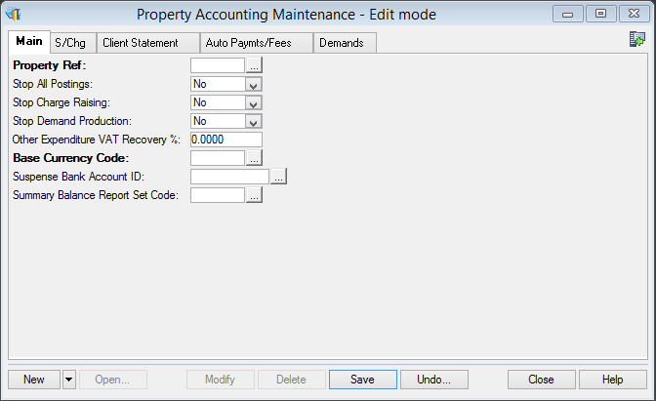

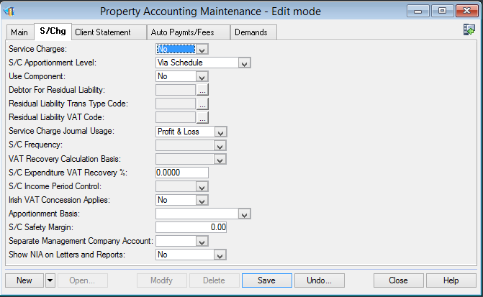

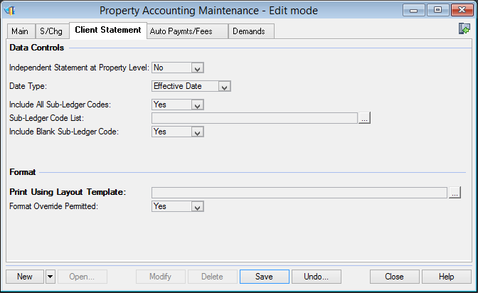

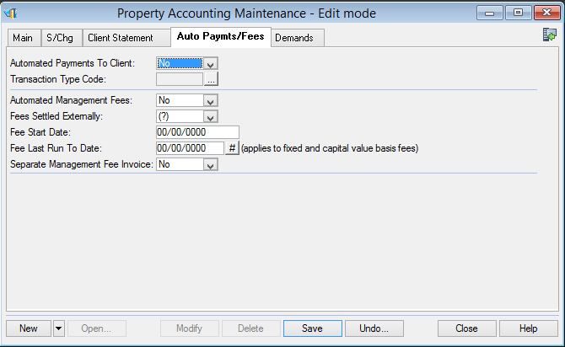

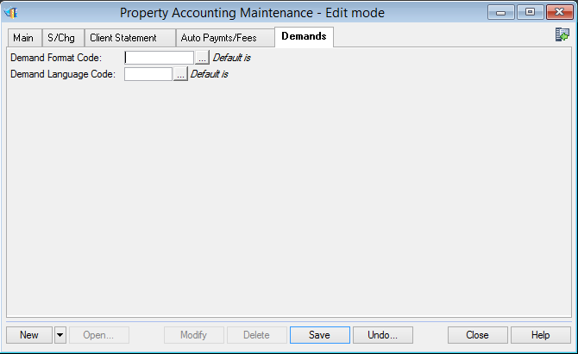

Unit

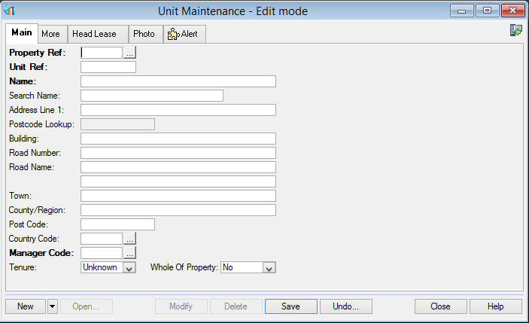

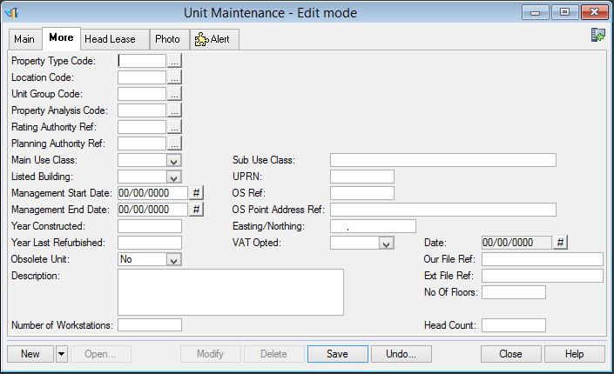

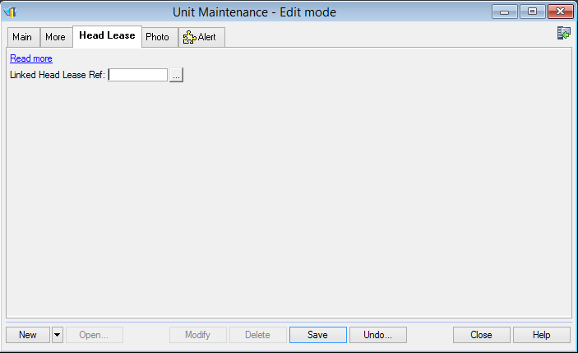

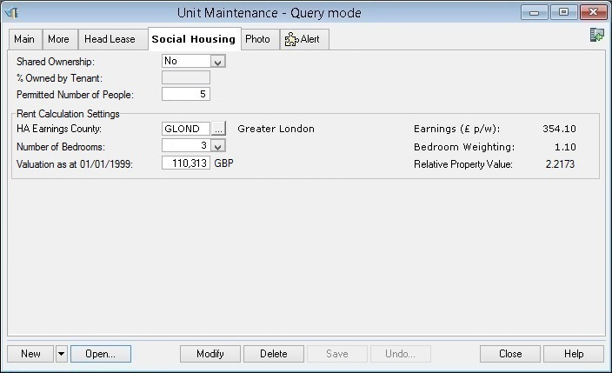

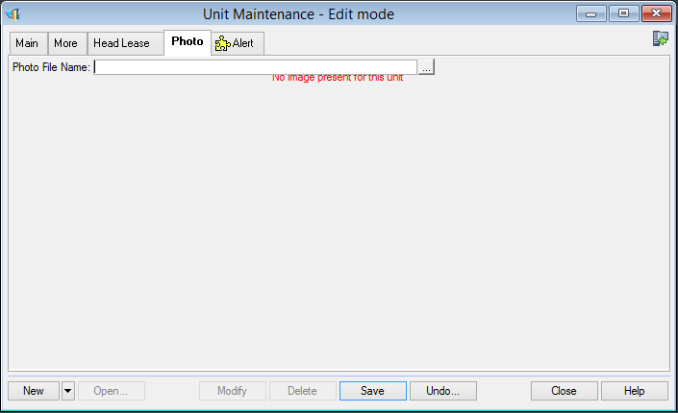

Tenant

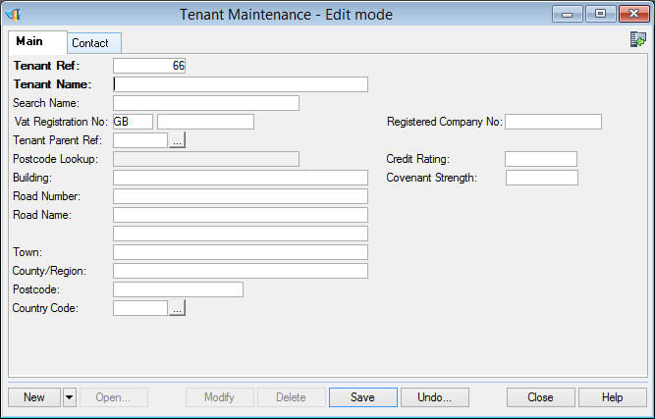

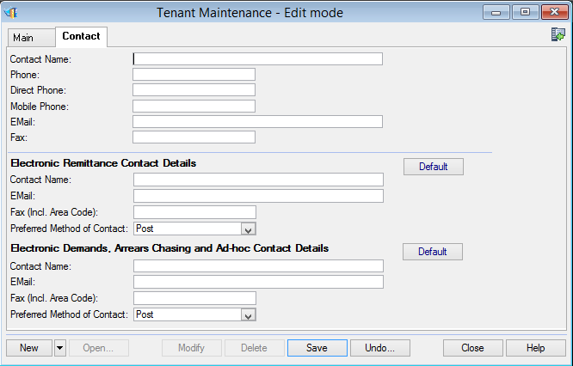

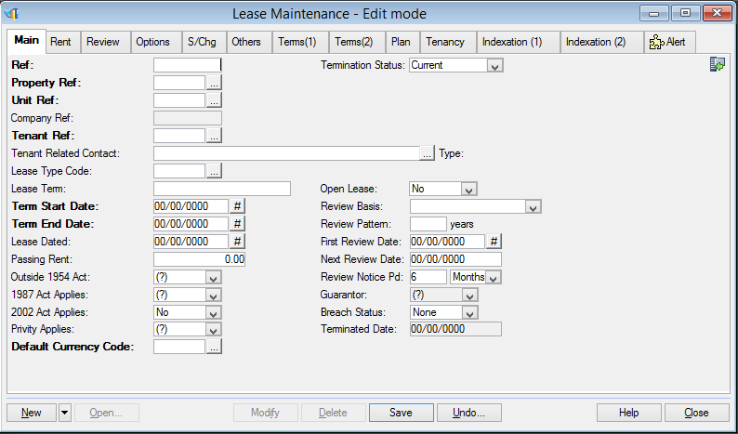

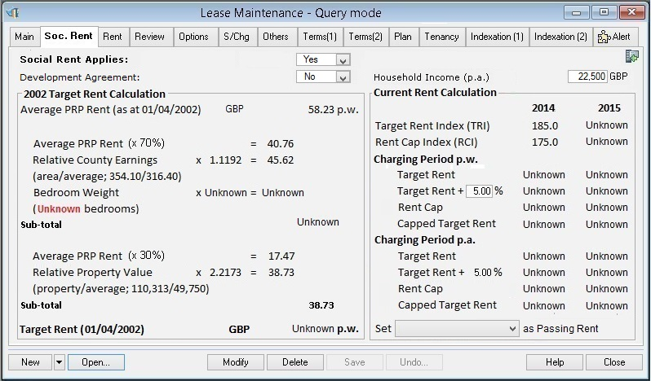

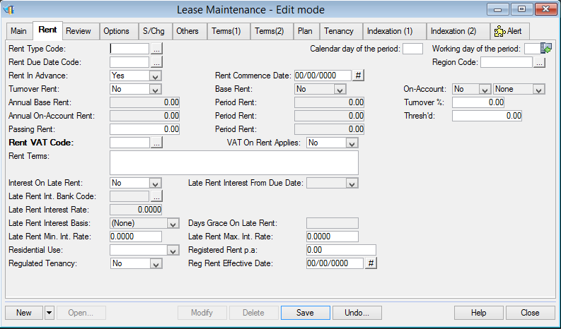

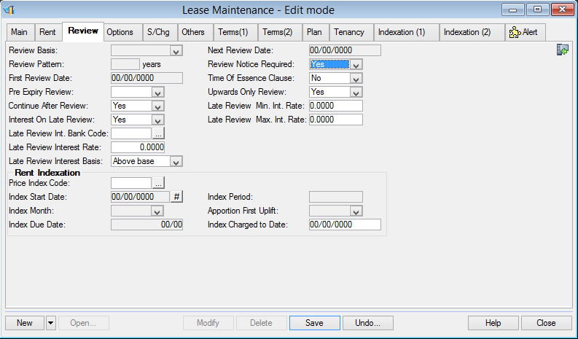

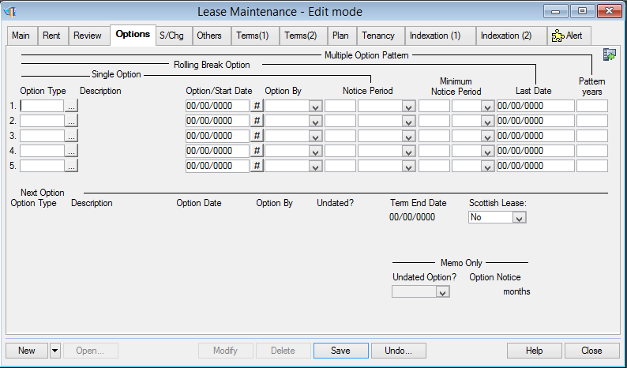

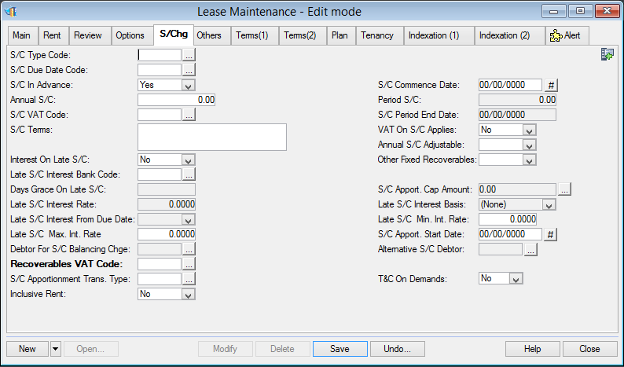

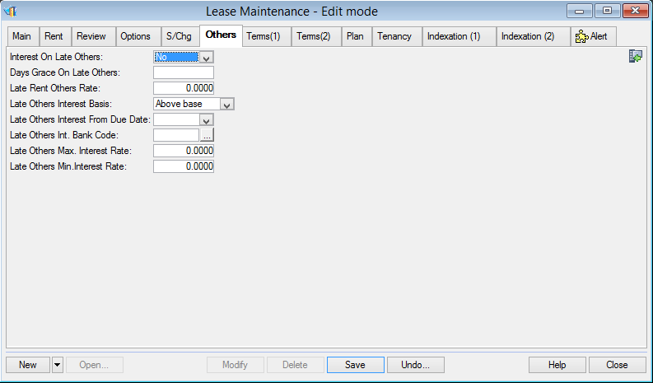

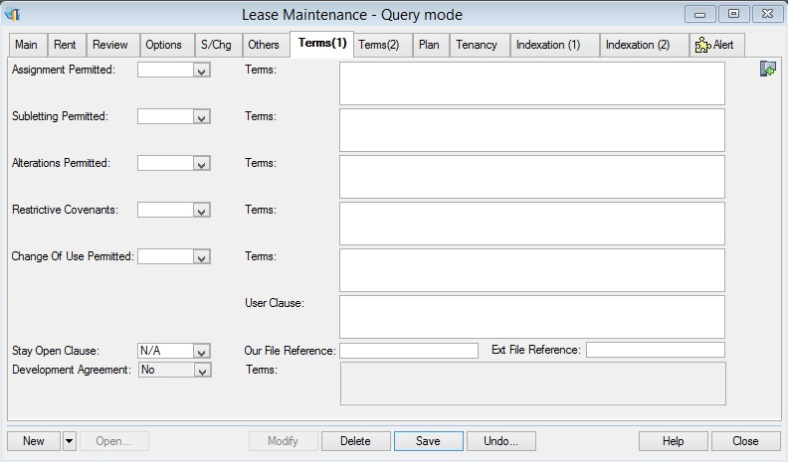

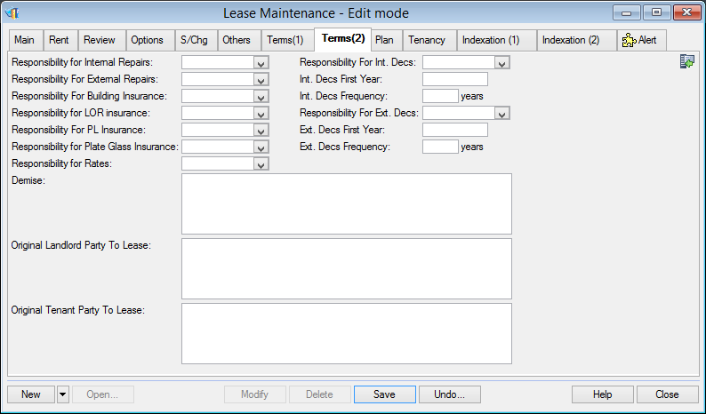

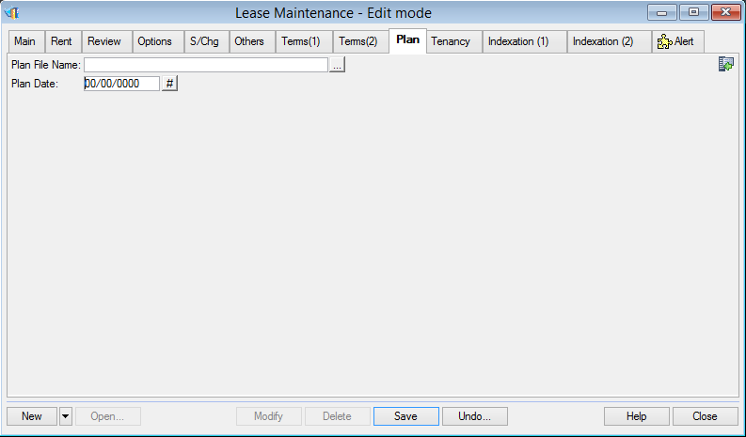

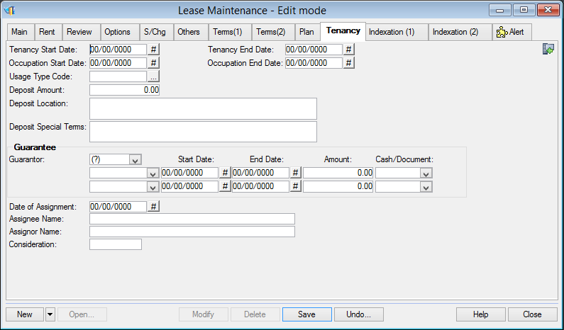

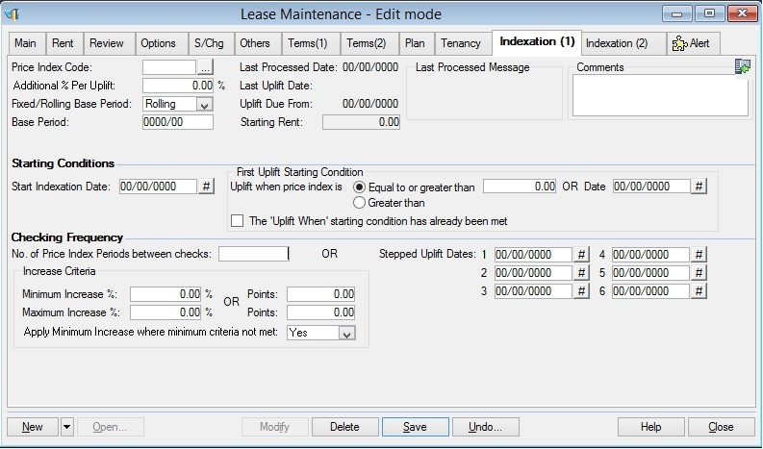

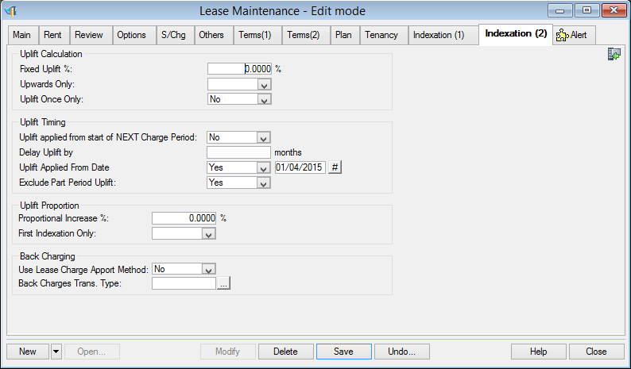

Debtor

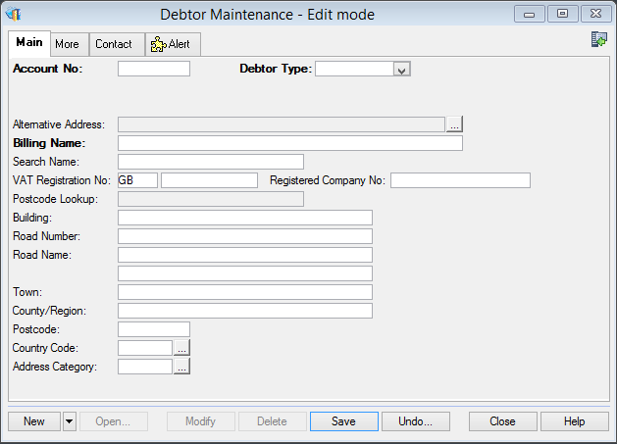

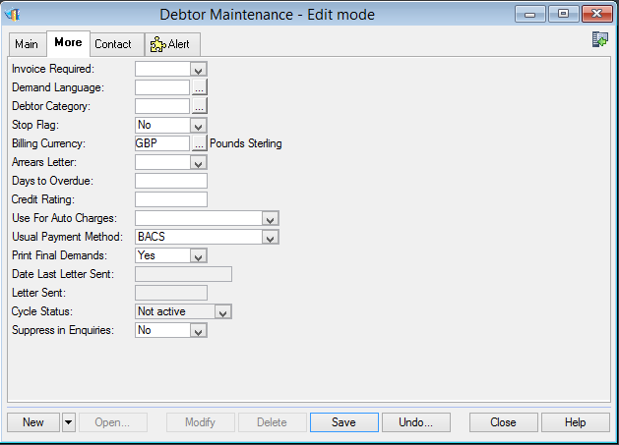

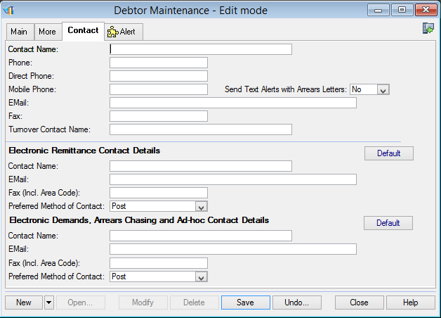

Creditor

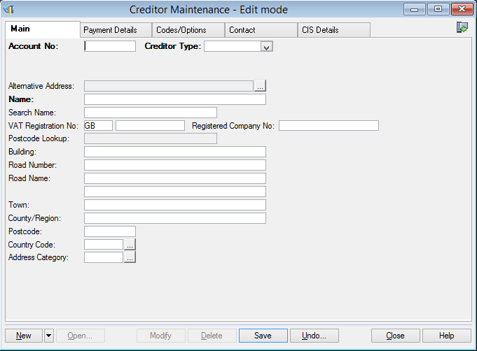

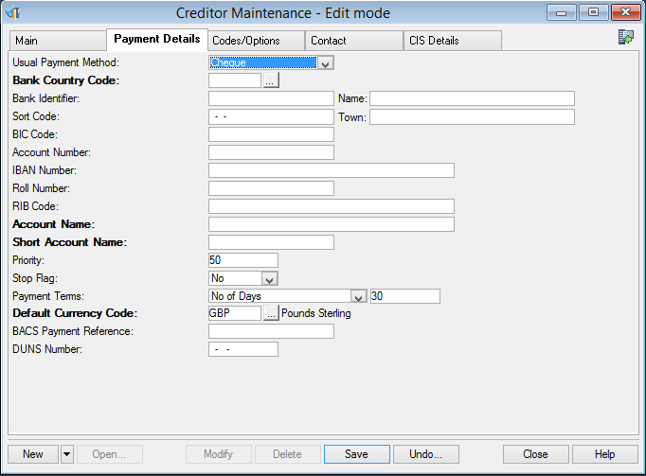

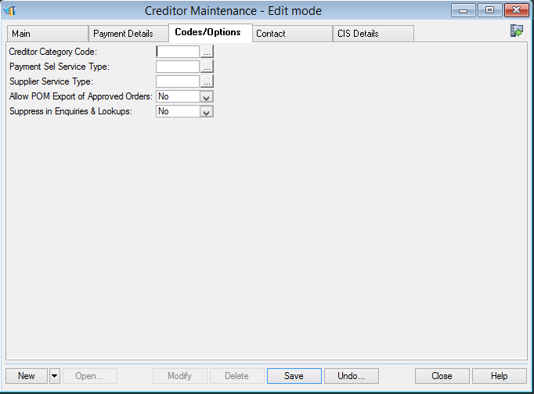

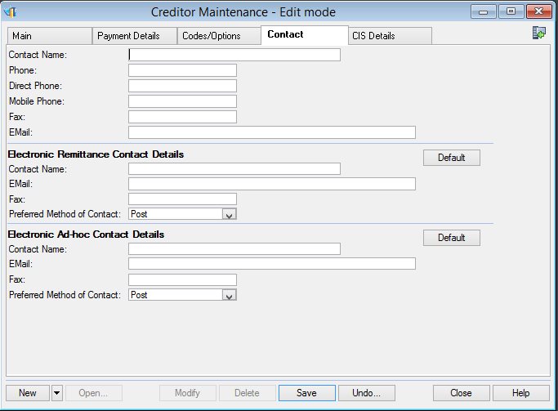

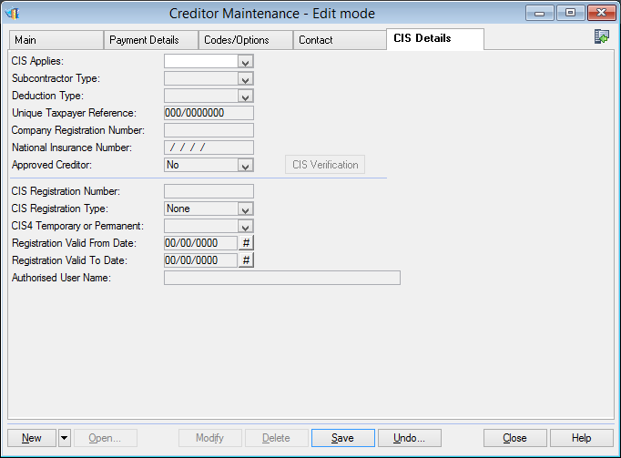

# Other Notes

## Performance

*Highlight any aspect of the changes that may cause performance problems, indicating probable record volumes.*

*Performance expectations for the issue should also be defined here.*

## Audit Considerations

*Note any auditing requirement over-and-above standard auditing.*

## Limited Access

*Note if any of the changes will be affected by limited access at client and/or property level.*

## Scheduler

*Note any impact on routines already schedulable.*

## Other Modules

*Note any impact on other modules, e.g. due to schema changes.*